EXP 6 Write a Servlet to demonstrate session tracking
using HttpSession.

AIM:
To demonstrate session tracking using HttpSession in a Servlet-based web
application. The exercise involves implementing a simple login system where a user can log
in with their username and password, and their session will be tracked throughout their
interaction with the web application.
ALGORITHM:
1. Input:
• The user will enter their username and password in a login form.
• The servlet will validate the credentials and create an HTTP session for the user if
authentication is successful.

2. Steps for Implementing Session Tracking with HttpSession:
1. Create the Login Form (HTML):
o Create an HTML form with two input fields for username and password.
o Provide a submit button to send the data to the servlet for authentication.
2. Create the Login Servlet:
o Write a Java servlet class to handle login requests.
o The servlet will:
▪ Retrieve the username and password from the form.
▪ Authenticate the user by comparing the credentials to a stored value
(e.g., hardcoded or from a database).
▪ Create a new HTTP session for the user if the credentials are valid.
▪ Set session attributes such as the user&#39;s username to track the session.

3. Validate User Credentials:
o In the servlet, check if the username and password match the expected
values.

13

o If valid, create a session and store the username in the session.
o If invalid, redirect the user back to the login page with an error message.
4. Create and Track User Session:
o Upon successful login, use the HttpSession object to store the session data.
o Use the session.setAttribute(&quot;username&quot;, username) method to save the
username.
o Optionally, set session timeout using
session.setMaxInactiveInterval(time_in_seconds) to manage session
expiration.

5. Redirect to a Protected Page:
o After a successful login, the user will be redirected to a protected page (e.g., a
dashboard or home page).
o The protected page should check if the user is authenticated by checking the
session attribute.
6. Logout and Session Invalidation:
o Provide a logout feature that invalidates the session using session.invalidate()
when the user logs out.
o After logout, redirect the user back to the login page.
7. Session Expiration:
o If the session expires or the user manually logs out, the session will be
invalidated, and the user will be redirected to the login page.

OUTPUT:
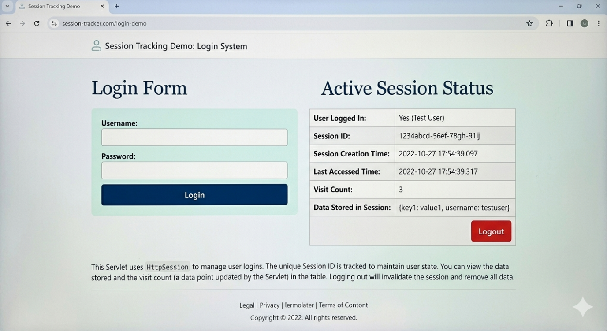

RESULT:
A simple login system is created where the user&#39;s session is tracked by a servlet to
demonstrate session tracking using HttpSession.

